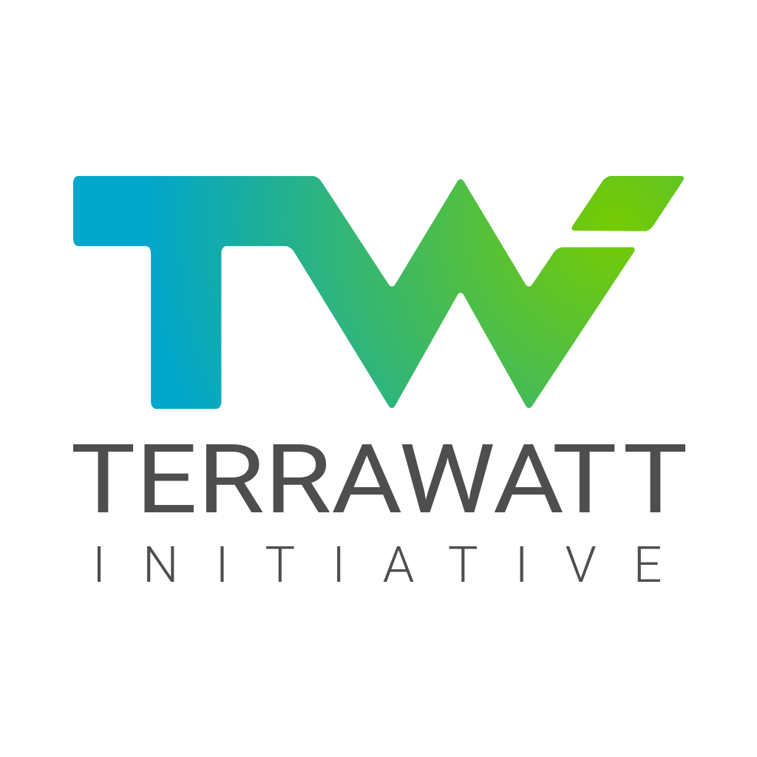

Press release

Renewable energies well below 2 cents per kWh
worldwide, before the end of the decade

Paris, June 24, 2020 - To achieve a successful energy transition, Terrawatt Initiative launches in its new report and on its new website (in English), the challenge of a solar kWh ‘well below’ 2 cents everywhere in the world before the end of the decade.

‘Well below 2 cents’. This simple but strong message resonating with the Paris agreement is the one the Terrawatt community is sending today to policy makers and citizens around the world.

Behind this message is a conviction: the energy transition is within reach. Bringing renewable electricity, particularly solar electricity, well below 2 cents per kWh means enabling an entire society and its economy to transform itself: the electrification of end uses, light, heat, mobility; storage; new energy carriers; green hydrogen; and many other socially indispensable innovations are becoming economically viable.

Only five years ago, well below 2 cents per kWh was considered unrealistic. Today it is a reality for major projects when public, industrial and financial authorities work together.

The challenge for the decade ahead is to generalise this price level everywhere and at all levels, especially for the most vulnerable. This is the ‘green deal’: to build together a new energy regime that allows everyone to have access to affordable, reliable, sustainable and modern energy.

Since COP 21 in Paris, Terrawatt Initiative has explored all the sticking points on the road to well below 2 cents per kWh. Bringing together a large number of partners, both public and private, Terrawatt Initiative has proposed concrete solutions for each category of stakeholder and has supported their implementation as far as possible.

Today, Terrawatt is very proud to share online with the general public the story of this formidable collective adventure, as well as all of its output, on its new website www.terrawatt.org.

"Based on our entrepreneurial experience in solar energy, we wanted to share some of the lessons learned from years in the field to systematically reduce the cost of renewable energy to less than 2 cents per kWh and thus pave the way for a profound and necessary transformation of the energy system" said Jean-Pascal Pham-Ba, Secretary General and spokesperson at Terrawatt Initiative. "All of the ideas we have proposed: de-risking, pooling, aggregation, granularity, standardisation, etc. are now widely accepted. They are coming to life in operational tools such as the Open Solar Contracts [of IRENA], the Sustainable Renewables Risk Mitigation Initiative [of the International Solar Alliance, IRENA, the World Bank and the French Development Agency], and others", he added. "This would not have been possible without a great team and the continuous support of our members and partners". He concluded: "Well below 2 cents per kWh everywhere. I am convinced that together we can achieve it. And that it can be done before the end of this decade”.

“Transforming a world dominated by fossil fuel to one largely based on renewable energy calls for visionary acts. That’s why I wanted to fly around the world on solar energy with Solar Impulse – demonstrating that technologies exist that allow us to achieve the impossible” said Dr Bertrand Piccard, Chairman of the Solar Impulse Foundation. “The Terrawatt Initiative was another such visionary act, recognising that the rapid uptake of solar energy in key solar markets would not happen if private stakeholders failed to guide states and financial institutions through the needs of an evolving market. This initiative was instrumental in mobilising the right forces to positively shift the trajectory of solar energy on the global stage” added Piccard. “It has been an honour to follow your work over these years and to recognise that a ‘well below 2 cents’ price is indeed achievable”.

“In august 2019, Akuo broke a world-record price in Portugal, well below 2cts, namely 1,47cts, the lowest price in Europe. Our success is a demonstration of the Terrawatt Initiative’s conclusions: it is feasible to go well below 2 cts” said Eric Scotto, CEO of Akuo Energy. “To achieve such a price, and in accordance with the conclusions of the initiative, it is necessary to (1) adopt a long-term position in a given country; (2) aggregate projects so as to benefit from the volume both for construction and financing; and (3) de-risk the investment thanks to long term PPAs. These conditions cannot be met if a government fails to provide long-term signals about its renewable energy policy and ambitions: bold decisions by governing bodies are thus key. Akuo believes Portugal is leading by example and we trust this trend will continue across a large part of the world” added Scotto. “Terrawatt initiative was certainly instrumental in pushing the right frameworks in solar-rich countries”.

“Driven by impressive cost-reductions, renewable power has become mainstream and that is great to see. Continuous cost reduction and a price of « well below 2 cents » can accelerate the spread of renewable power globally” said Rana Adib, Executive Director, REN 21. “But the progress in this one sector should not lead us to believe that renewables are a guaranteed success. Governments need to take action to achieve this target and create the rules and the environment to switch to an efficient and renewables-based energy system” added Adib. “Not only for economic reasons, but to meet climate goals, reduce air pollution, create economic opportunities and sustainable jobs”.

Thierry Lepercq, Founder of Soladvent, said “Terrawatt Initiative has the right vision, with innovative proposals for how to achieve it. Solar below 2 cents per kWh is not just a cost milestone, it is a reality that sets the stage for a global exit from fossil fuels and ultimate victory in the fight against climate change”.

About Terrawatt Initiative

Launched at COP 21 by a group of energy, industry, technology and finance visionaries, Terrawatt Initiative is an entrepreneurial effort to answer the tough questions of the energy transition: how can a nascent clean energy system outcompete the existing fossil fuel system at global level? How to outcompete a system which is so deeply embedded in our societies? How is it possible within ten years?

Terrawatt Initiative advocates for an open public-private dialogue to reach a new deal and co-construct a new solar market capable of delivering solar power at well below 2 cents per kWh as the foundation of the new energy regime.

Contact: Terrawatt Initiative — Jean-Pascal Pham-Ba — jppb@twi.team — +336 7272 4756— www.terrawatt.org

